=====================================================================

SET 5

Q1. (Data Structures – 5 Marks)
Using AI tools, implement a Linked List in Python with operations:
- Insert at beginning
- Insert at end
- Delete a node
Display the list after operations.

Prompt: Using AI tools, implement a Linked List in Python with the following operations:
• Insert a node at the beginning
• Insert a node at the end
• Delete a node by value
• Display the linked list after each operation
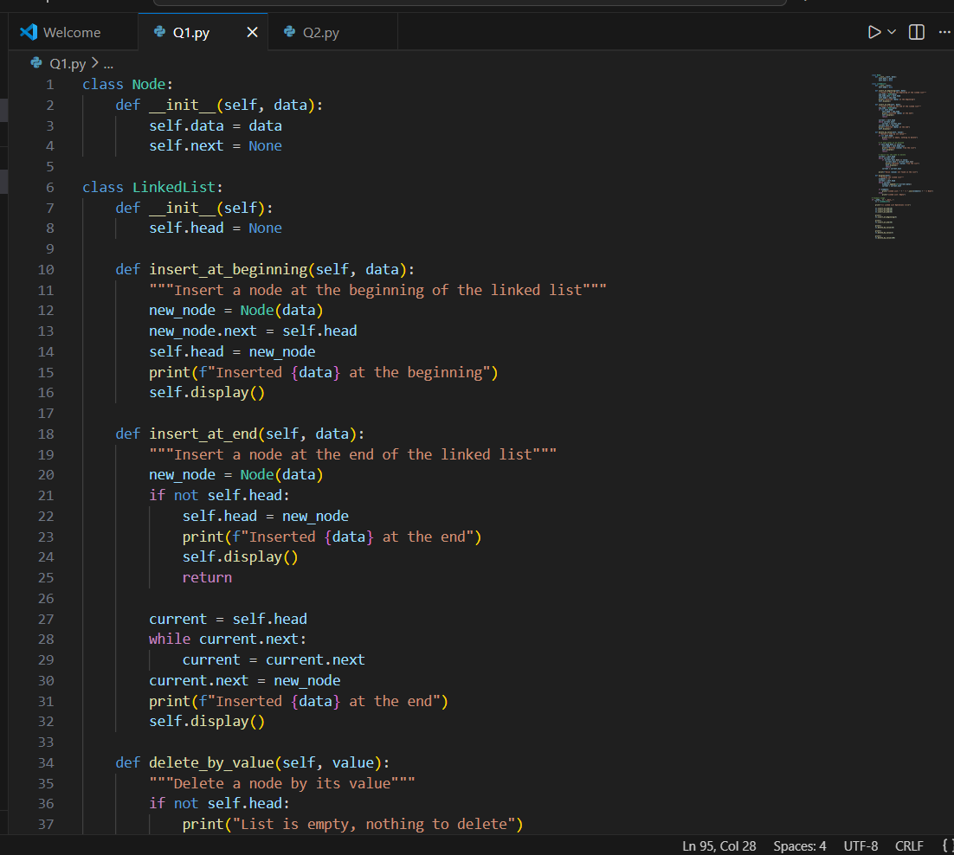
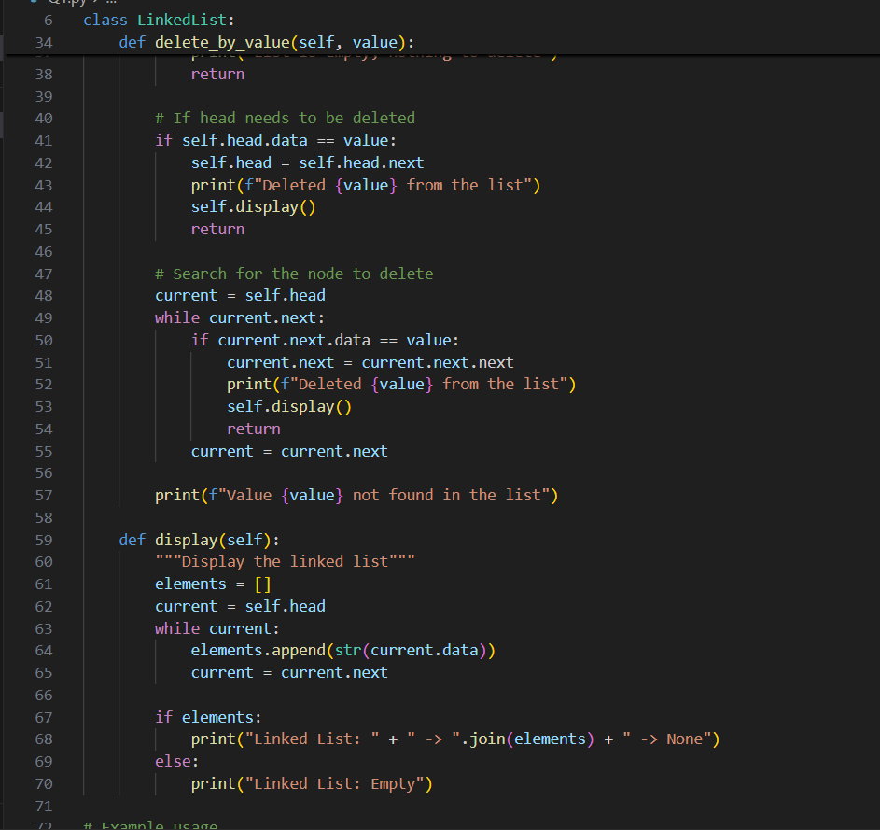

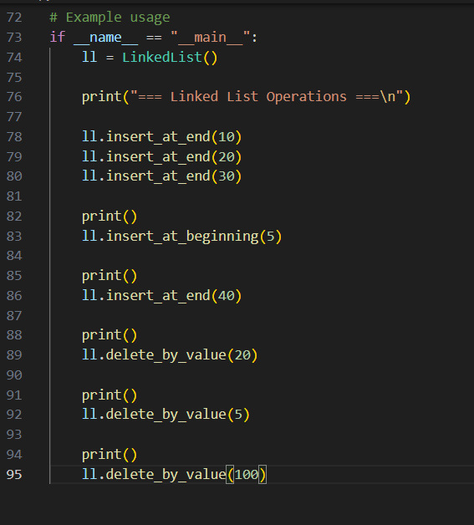
OUTPUT :

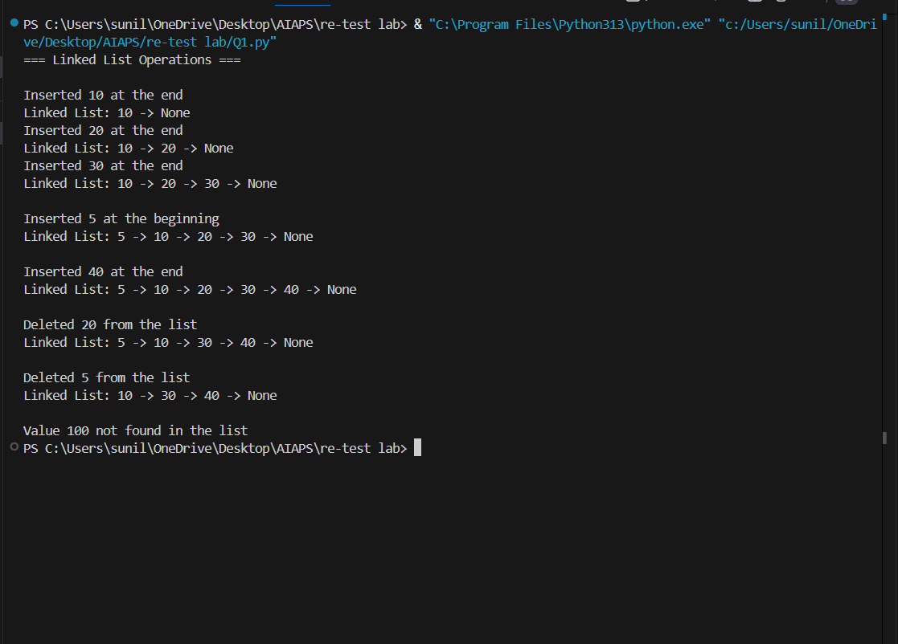

Q2. (Web Frontend – 5 Marks)
With AI assistance, generate a responsive Portfolio Website Layout including:
- Header
- About section
- Projects section
- Contact form

Prompt: With AI assistance, generate a responsive Portfolio Website Layout using HTML and CSS, which includes:
• Header
• About section
• Projects section
• Contact form
Make sure the layout is clean, responsive, and visually appealing.

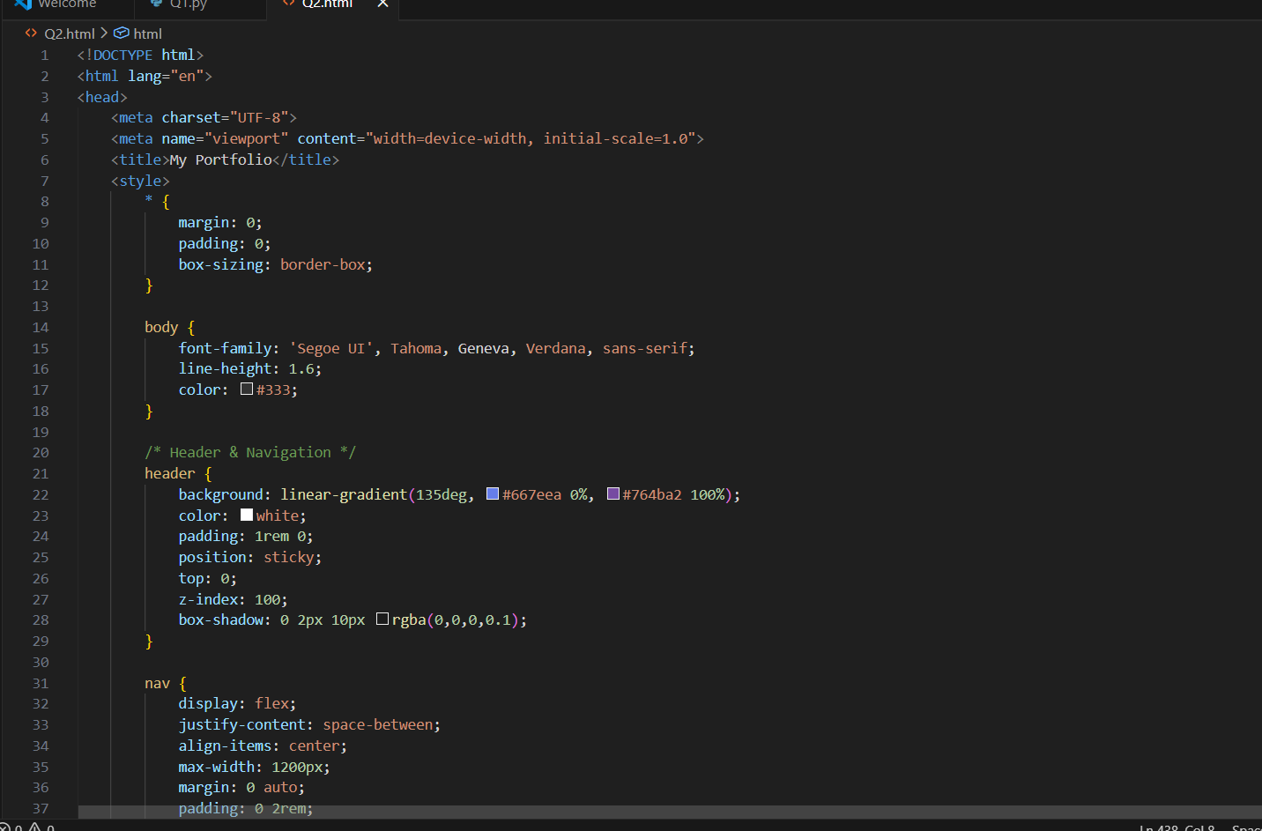
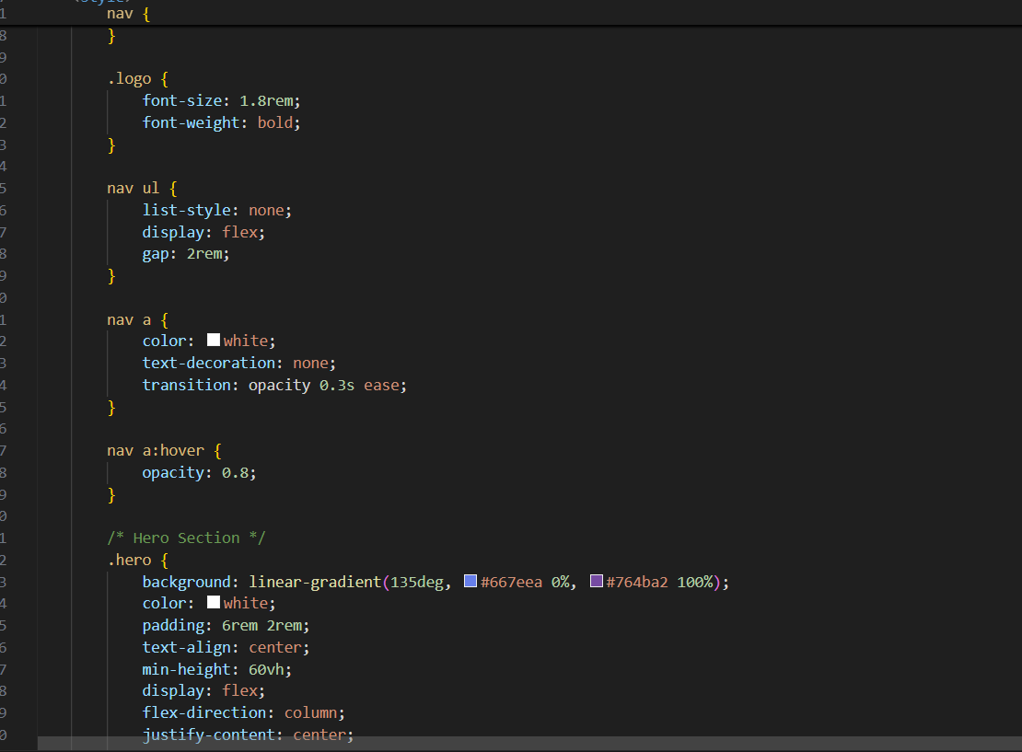
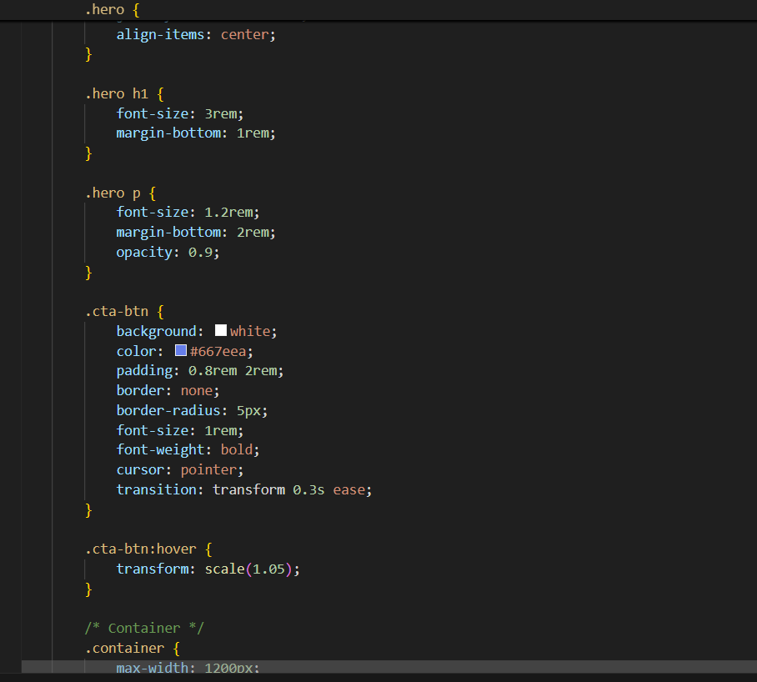
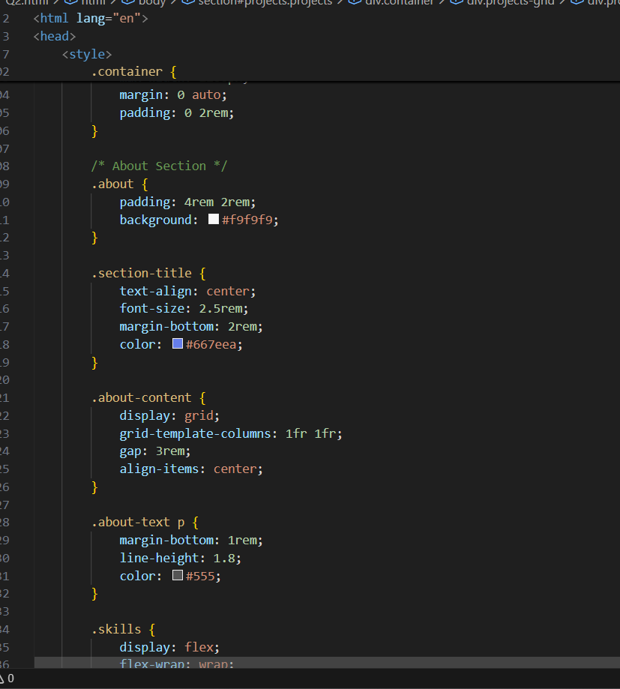
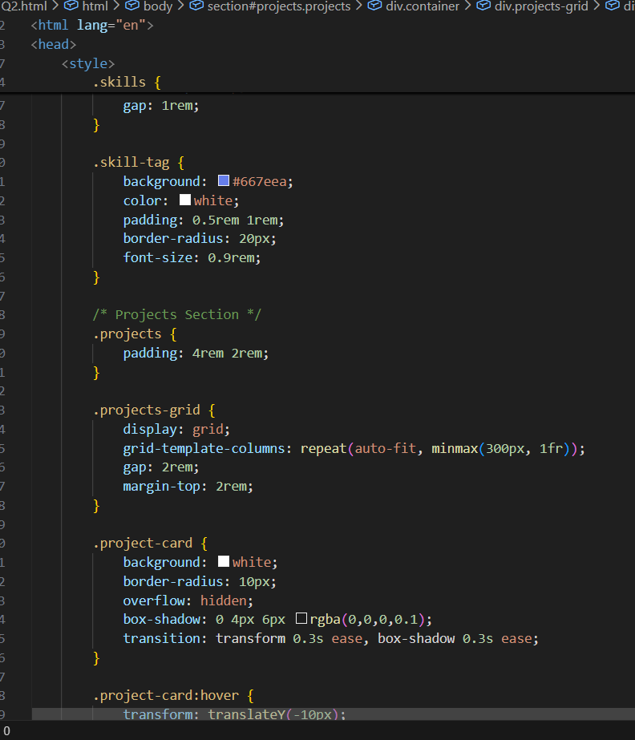
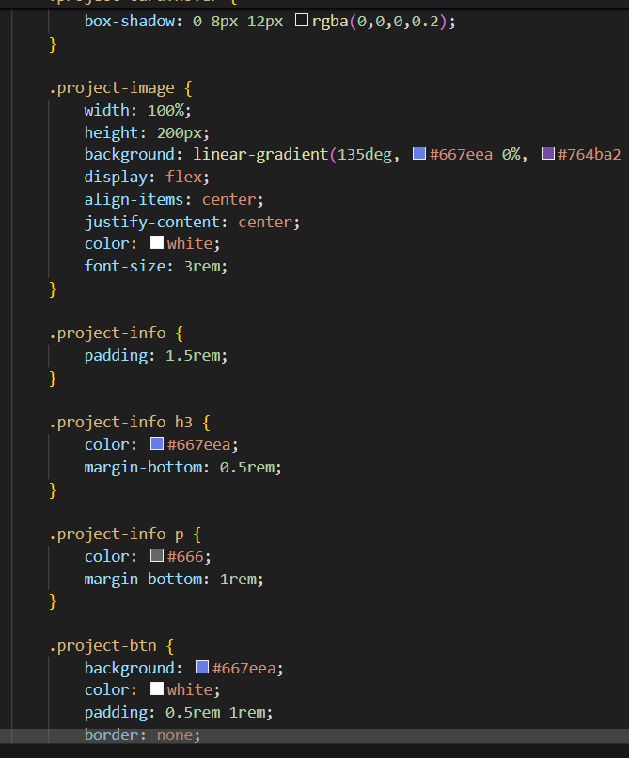
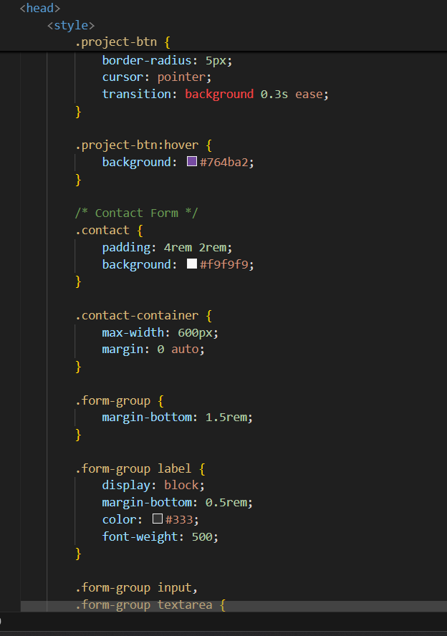
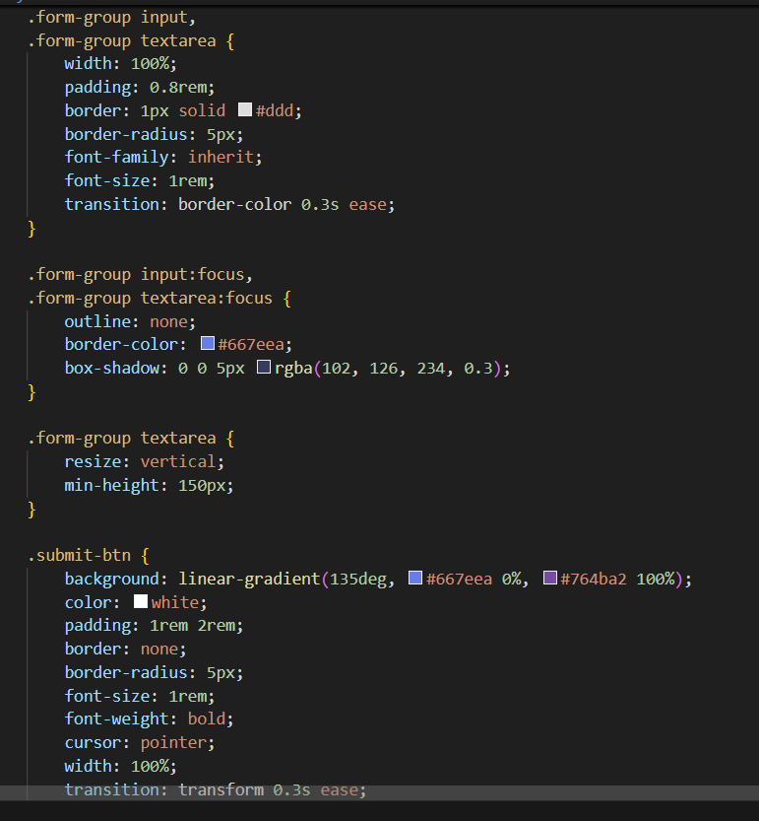
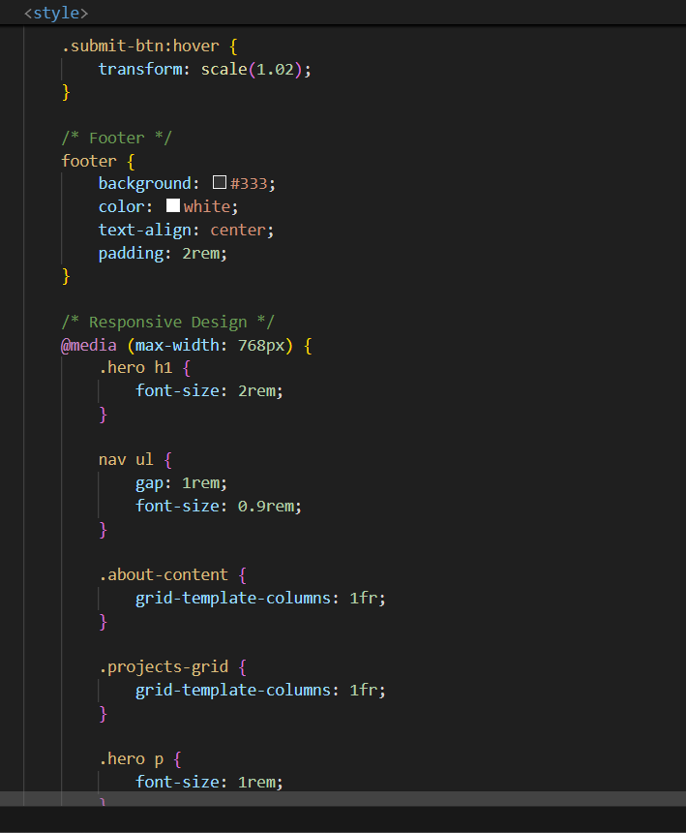
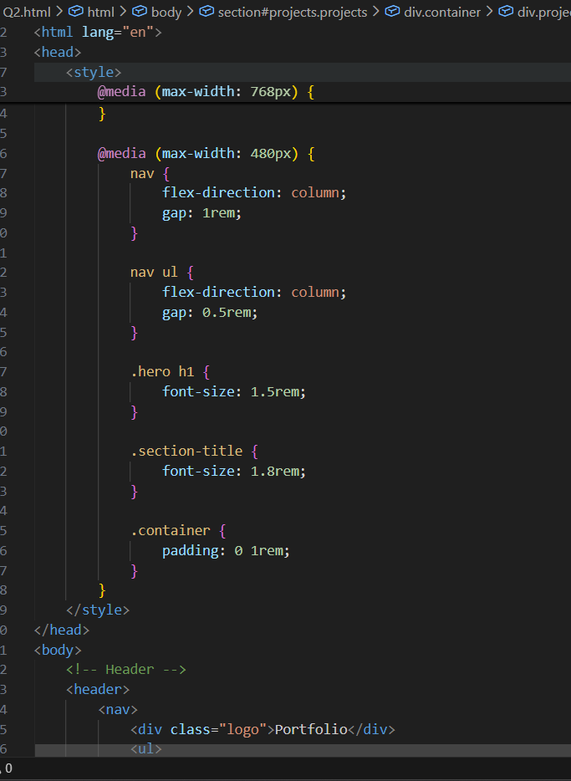
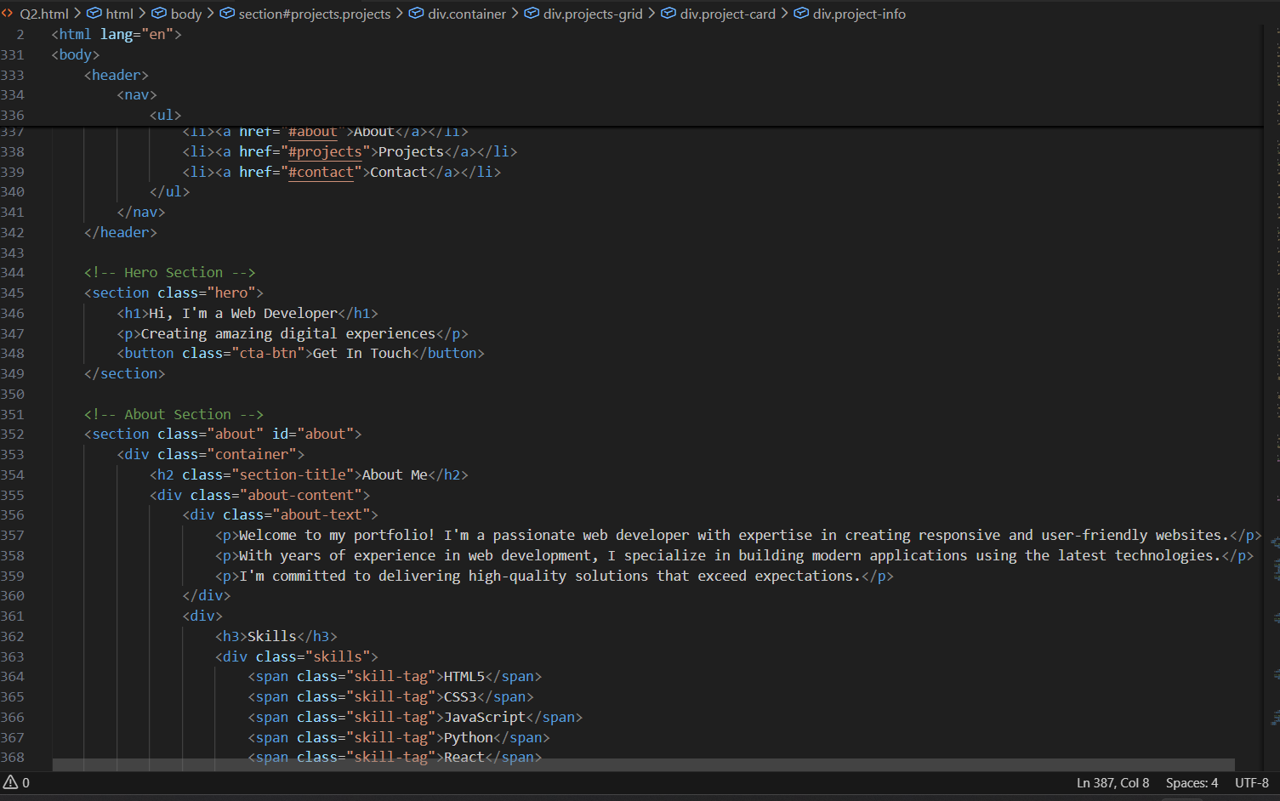
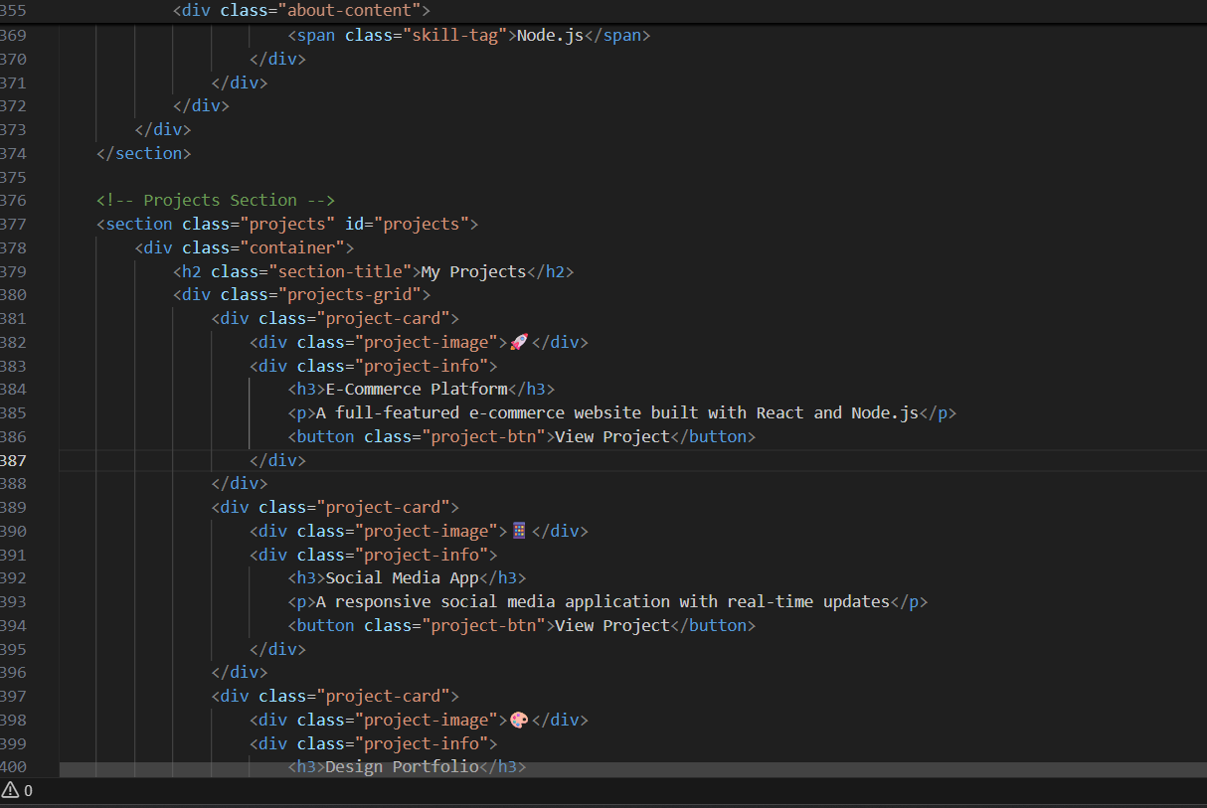
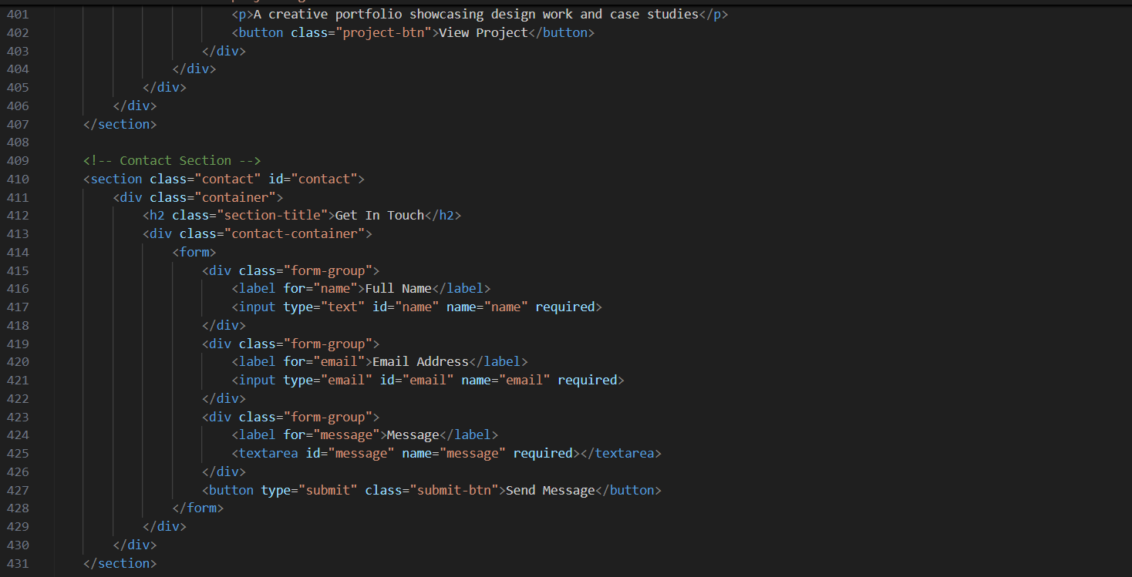
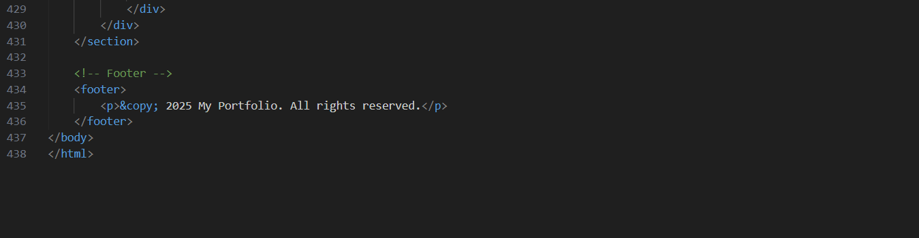
OUTPUT :
